S-Anon Panel Discussion for Professionals*

The format for a one-hour panel discussion may include the following components, each 15 minutes in length:

- What S-Anon is and isn’t
  - Twelve Step program like Al-Anon
  - Includes S-Ateen
  - Data as of June 2017 – revise as needed
    - 335 face-to-face groups
    - 8 phone meetings
    - 2 Zoom meetings
    - 11 Skype meetings (including 1 each Dutch, Italian, Russian, Slovak, 4 Spanish
    - 13 couple meetings
    - 2 S-Ateen meeting, F2F in Madrid and Jerusalem
    - 3 S-Anon online meeting, including 1 Spanish
- How sex addiction consumed one S-Anon’s life and how S-Anon made a difference
- The family disease of sex addiction across generations and how S-Anon helped
- Q and A

Materials to hand out:
- S-Anon for Helping Professionals: a single page handout that lists all available materials for professionals, summarizes the content and includes the cost to order.
- S-Anon for Professionals sample page from the sanon.org website.
- S-Anon Contact cards with local contact information, if possible

*Professionals may include Human Services Spiritual Leaders, Doctors, Social Workers, Lawyers, Law Enforcement and Criminal Justice professionals

S-Anon for Helping Professionals

S-Anon International Family Groups, Inc. has a long history of cooperation with professionals who work with those affected by the sexual behavior of family members or friends. Doctors, nurses, counselors, therapists, social workers, clergy, attorneys, judicial, law enforcement, employee assistance and human resources personnel are just a few of the professions that find their clients/patients can benefit from S-Anon/S-Ateen.

Resources Available at www.sanon.org

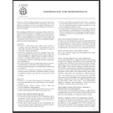 | Information for Professionals About S-Anon and S-Ateen Family Groups  An informative tool to help S-Anon members, groups and intergroups carry the message to the professional community. Also available as a free download.  $0.25
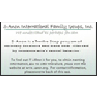 | S-Anon Contact Card for Professionals - Package of 12  Business card size; package of twelve. May be used alone or with our leaflet Informational for Professionals as part of the local12th Step outreach to professionals.  $1.00
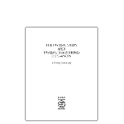 | Twelve Steps and Twelve Traditions of S-Anon - A Brief Summary  A brief summary of the main ideas underlying each of the Twelve Steps and Twelve Traditions, outlined in a 24 page pocket-sized booklet. Also available as a free download.  $1.50
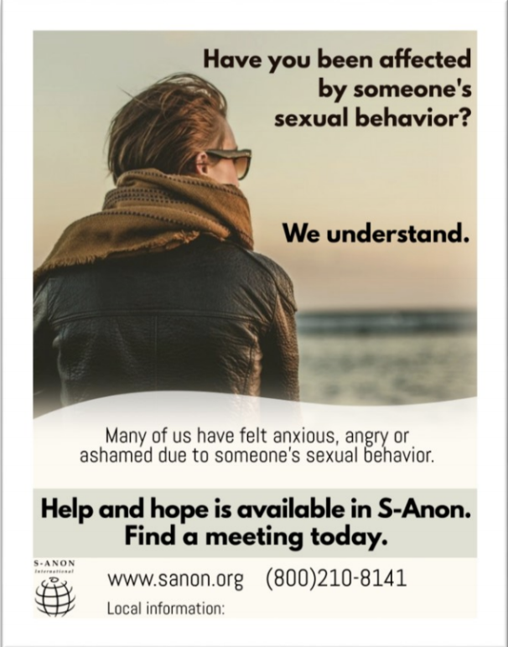  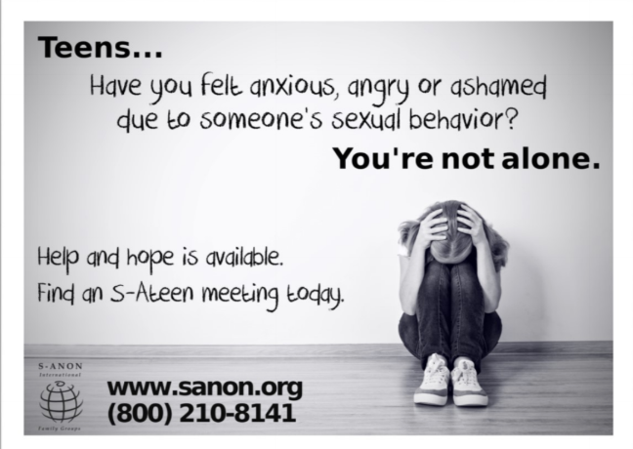 | S-Anon Public Information Posters  Full color 8-½” wide x 11-½” poster to be used to inform the public about how and where to contact S-Anon International Family Groups.  $1.50

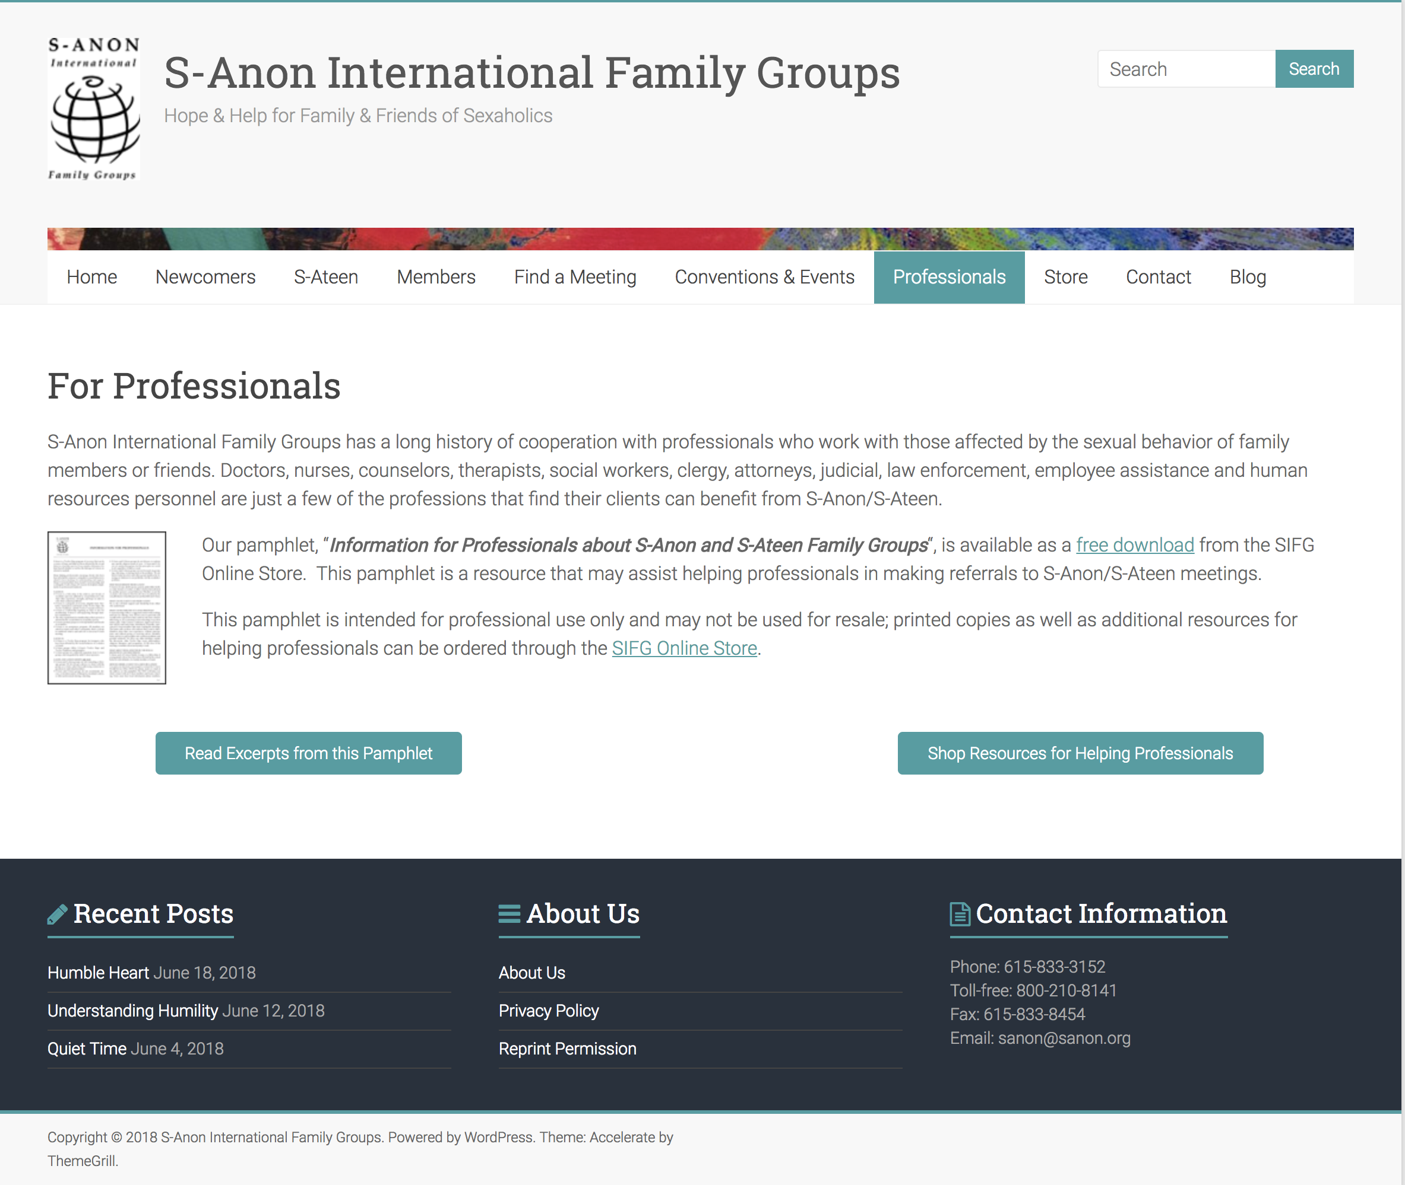

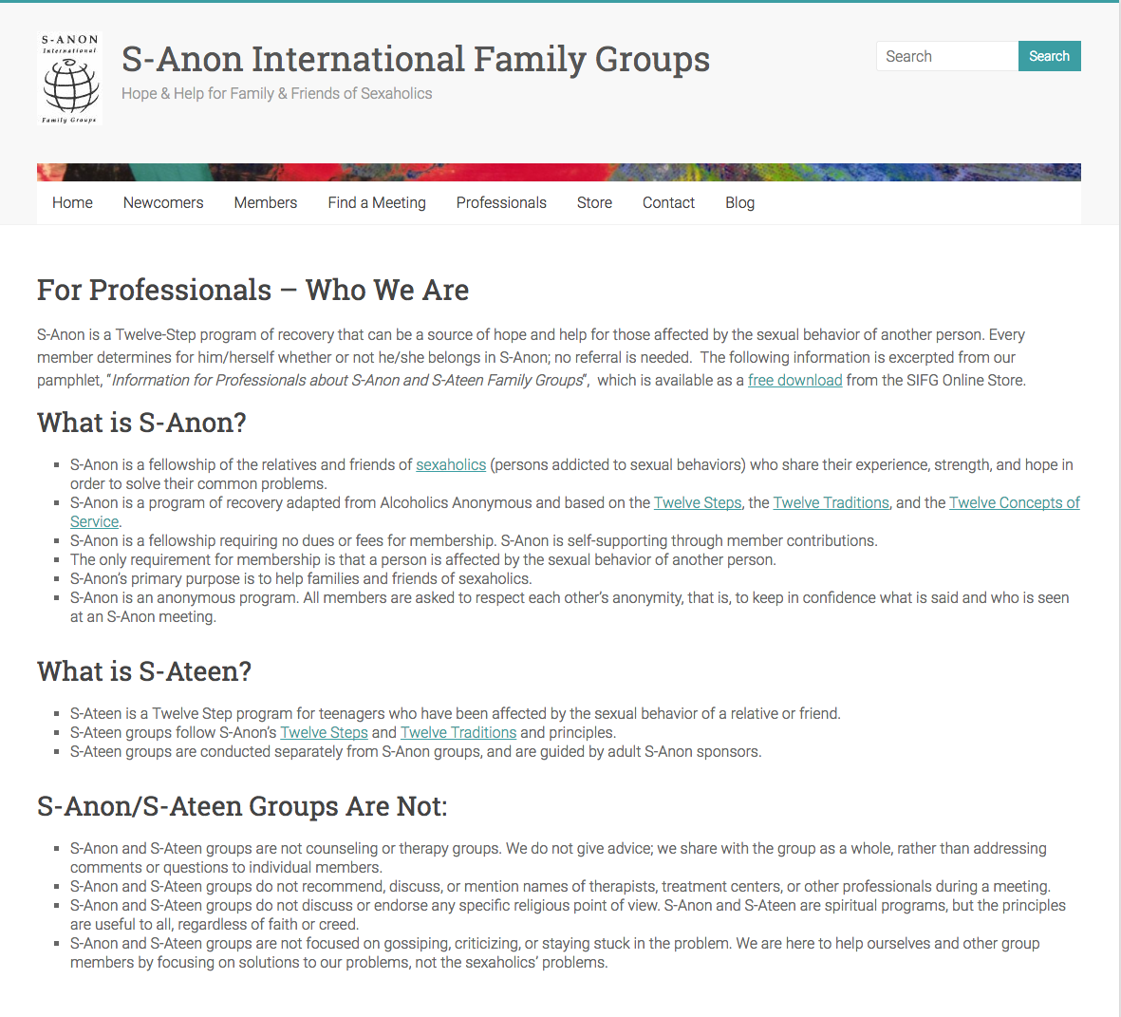

Helpful background information on S-Anon’s early history

The following information is adapted from a recent WSO Update newsletter, offering a brief timeline of S-Anon’s history based on interviews with early members, questionnaires, taped speakers, written personal stories, letters, official business documents, and S-Anews publications. Because of the number and variety of sources, some discrepancies were found and over time, they hopefully will be resolved.

1981 - 1982
A few spouses of recovering sexaholics independently start meetings in various locations across the country. However, within a short period of time they soon disband. At least one meeting is called “S-Anon”, mimicking the Al-Anon program.

1983
May—The longest sustained S-Anon meeting known to date is started by Jo Ann H. and Gene J. in Oklahoma City, OK.

December—SA Conference in Simi Valley, CA where six spouses hold their own meeting. They get organized and as a result of their efforts the S-Anon fellowship took hold. December 1983, S-Anon is officially established.

1984
The first central office is established by Joy T. and Jeannette B. in Phoenix, AZ.

Spring—The Co-Addicts Check List, first known published S-Anon literature, is co-authored by Joy T. and Jeanette B. from Phoenix, AZ

December—National conference held in Phoenix, AZ. Among S-Anon attendees are Gerry P. of Los Angeles, CA and Gene J. of Oklahoma City, OK

1985
The longest sustained meeting in California is established in West Los Angeles, CA by Gerry P.

December—A National Conference is held in Oklahoma City, OK. Jo Ann H. is elected chairperson. A month later the S-Anon Central Office is moved from Phoenix, AZ to Oklahoma City, OK

1986
A group os S-Anon members from West Los Angeles, CA meeting, initiated by Nona C. and Gerry P., start to work on writing the first edition of the S-Anon Step Study. That original writing becomes the basis for our current “S-Anon Tweleve Steps,” also known as the “Blue Book.”

1987
June—S-Anon business meeting at the Bozeman Conference discusses moving the Central Office to Los Angeles, CA and approves the formation of a committee to act as liaison to the Central Office. This was the precursor to the SIC (S-Anon International Committee).

Dear Abby contacts S-Anon about the mention of S-Anon in her upcoming newspaper column. The Los Angeles, CA members quickly develop contact information. Dear Abby publishes her column “Wife suspects man’s appetite for sex is really an addiction.” Los Angeles members respond to approximately 50 letters received as a result of the published column.

1988
The West Los Angeles, CA meeting sponsors the first S-Anon couples meeting.

A record number of 20 S-Anon members attend the Rochester, NY convention.

1989
February—The first S-Anews newsletter is published. The S-Anews remains an important part of S-Anon until the publication of our last issue in Summer 201.

1993
S-Anon’s first official incorporation takes place in Oklahoma.

1994
Fall—The World Service Office moves to Nashville, TN

1996
November—The first S-Ateen meeting stats in Clinton Township, MI.

1998
The first S-Ateen literature is published.

2000
Our first book is published: S-Anon Twelve Steps.

2004
January—First World Service Conference is held in San Diego, CA.

